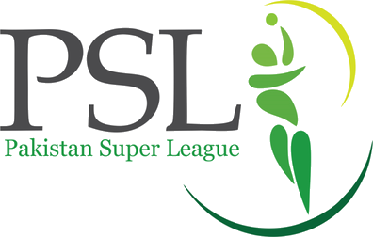
This Photo by Unknown Author is licensed under CC BY-SA

Pakistan super league
PSL is a cricket league of Pakistan that was begin from 2016 with five and there are 10 season done of psl and in PSL there are six teams Lahore Islamabad karachi multan Peshawar and quetta and in PSL Lahore and Islamabad have won 3 titles while all other team have won 1 title PSL is one of the biggest league of cricket and also one of the most famous league

